**CPNT-302B (Wireless Networking Fundamentals)**

**The MJAJ Group is providing WLAN Design and Validation for the First Floor of the SAIT Senator Burns Building.**

**Project Done By:**

Mission Rana: 000925767

Andy Kim: 000925655

Jonathan Viraphanh: 000581221

Joshua Singco: 000870569

**TABLE OF CONTENTS**

1. Introduction .............................................................................................................................

2. Requirements ...........................................................................................................................

3. WLAN Design for the Senator Burns Building at SAIT ..........................................................

4. Heatmaps of the Senator Burns Building .................................................................................

5. Implementation Plan .................................................................................................................

6. Bill Of Materials …………………...........................................................................................

7. Coverage and Performance Validation .....................................................................................

8. Recommendations for Post-Implementation Improvement .....................................................

**Introduction**

This project focuses on the design and implementation of a modern wireless network for an academic institute to accommodate a diverse and expanding user base. The network will be engineered to handle growing traffic demands while delivering seamless mobility and BYOD (Bring Your Own Device) support for faculty, students, and guests. It will enable flexible learning environments by supporting services such as video conferencing, allowing users to attend classes from any location on campus.

**Requirements**

* **High-Density Areas:** Design for classrooms (40 students), Lab Rooms (60 students), and Theater room (120 Students) assuming each student connects with 2 devices. The design must support this high client density and ensure reliable performance under heavy user traffic.
* **Wireless Coverage in Corridors:** Basic coverage for mobile users.
* **Non-Mandatory Capacity Design:** Lunchrooms and restaurants require coverage but not high capacity.
* **Audio/Video Conferencing:** Mandatory in the study rooms to support online classes.
* **Open Areas:** Support up to 300 people for social gatherings.
* **Exclusion Areas:** No coverage required for elevators, washrooms, and stairwells.
* **Quality of Service (QoS):** Prioritize voice and video applications across the network.
* **5 GHz Network:** Mandatory, with optional 2.4 GHz coverage.
* **Multiple Networks:** At least three networks (Academic, Guest, and eduroam) with RADIUS authentication for academic and eduroam. Guest access requires a usage agreement.

**WLAN Design for the Senator Burns Building at SAIT**

1. **Overview**

The Senator Burns Building is recognized for its specialized facilities across various sections. The NL and NR sections primarily house medical classrooms, while the NK section features lab Rooms and culinary arts classrooms. The NJ and NH sections are designated for general academic classrooms, and the NN section includes the Advising Office, a theater room, and gathering areas that serves as a welcoming space for student interaction, collaboration, and informal events. The building also features modern amenities such as dining areas, lunch shops, and spaces for student collaboration, making it a vibrant and multifaceted venue for both academic and social activities.

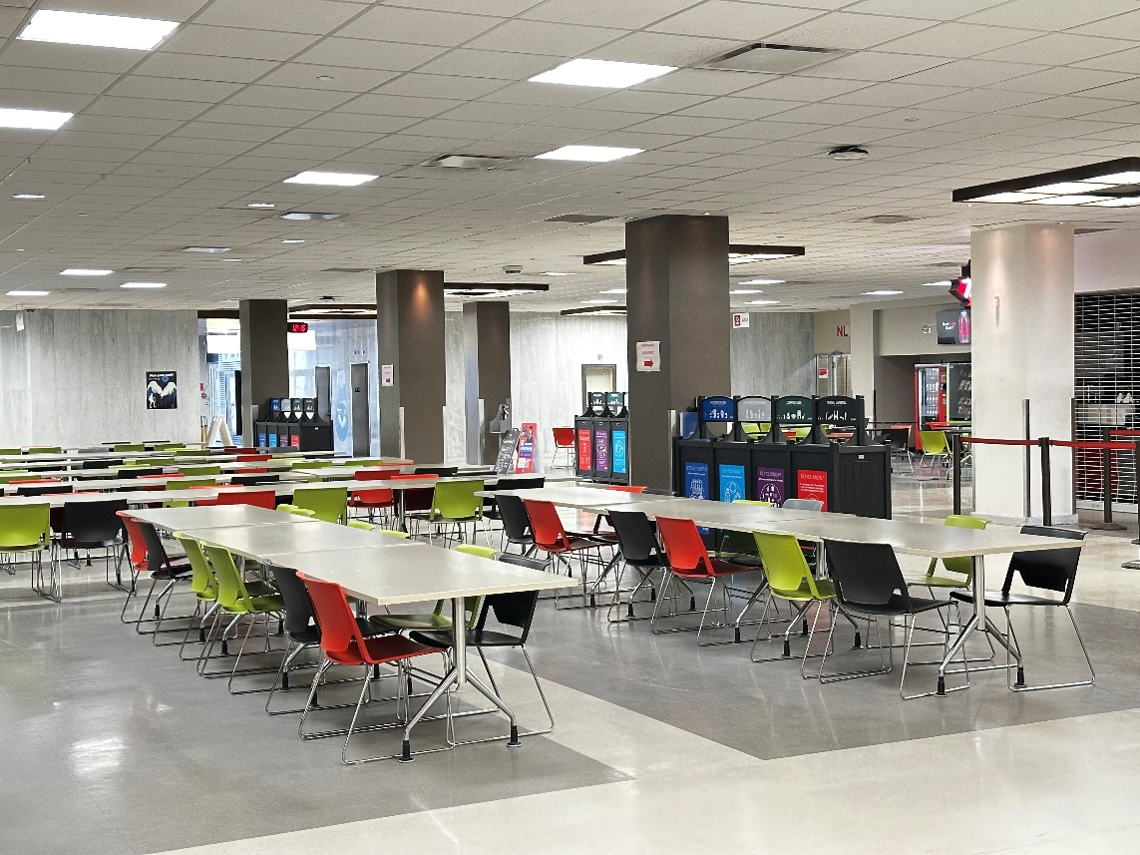

**Figure 1**

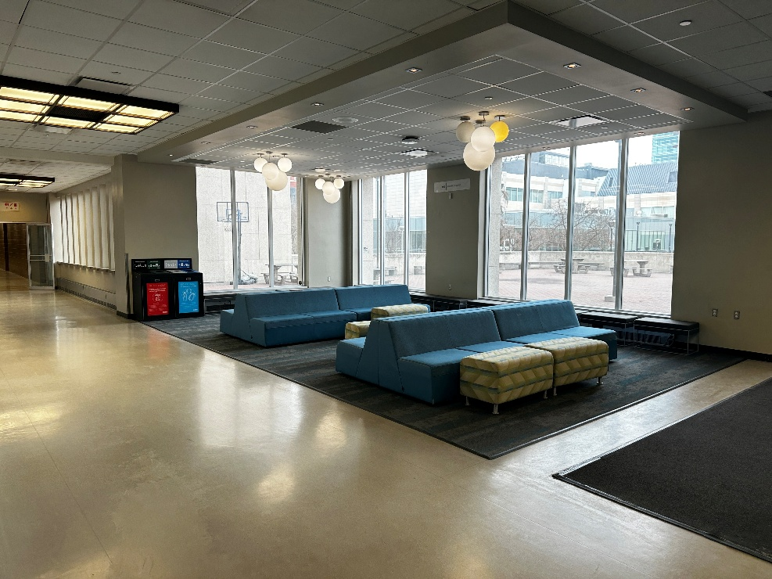

**Figure 2**

**(Gathering areas in NN section)**

The proposal includes surveying all the key areas of the first floor.

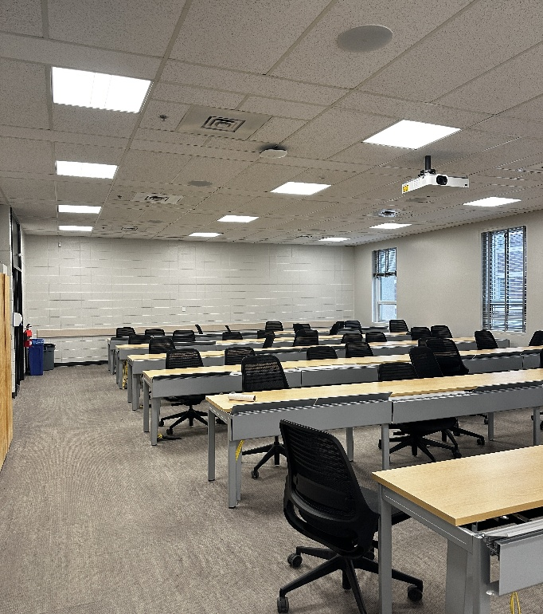

**Figure 3**

**(Overview of the Classrooms)**

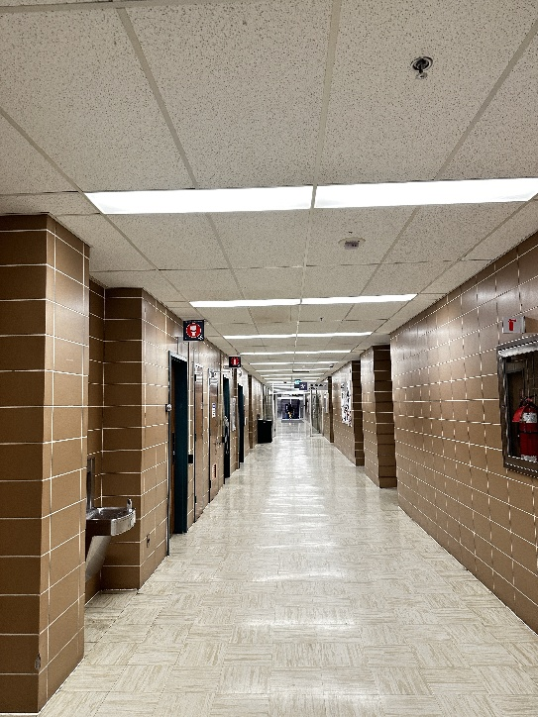 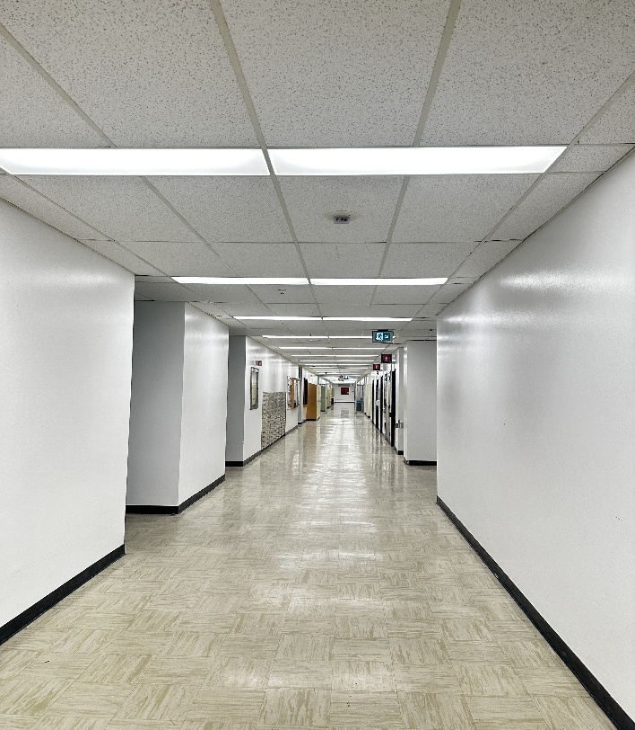

**Figure 4 (Overview of the Corridors) Figure 5 (The NK section differs in design)**

* **A comprehensive walkthrough survey of the floor was conducted, during which key areas and the wall types of each section were thoroughly investigated and documented.**
* **Dimensions:**

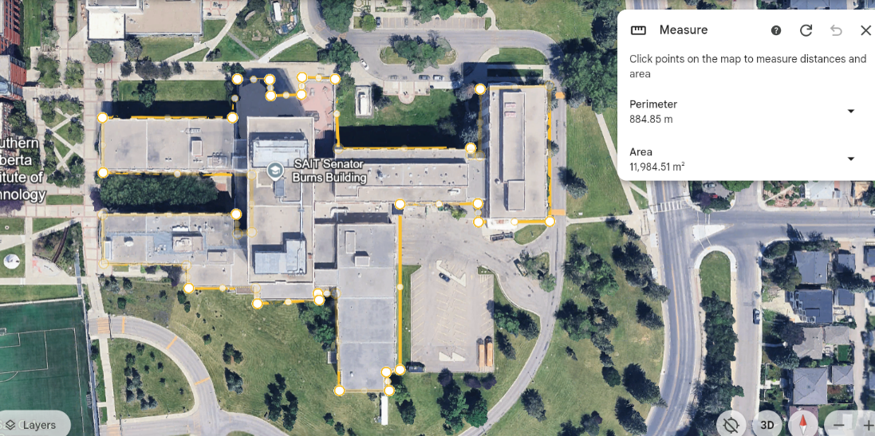

**Figure 6**

The building's dimensions were obtained using Google Earth’s measurement tool, ensuring precise WLAN predictions in Extreme Cloud IQ. Accurate measurements are essential for optimal AP placement, accounting for signal attenuation due to structural elements, and ensuring a reliable wireless network design**.**

1. **Site Survey Findings and Mapping in the Extreme Cloud IQ**

* **Wall Types and Attenuation:**
* **Classrooms and offices:** The inner walls are primarily constructed of drywall,

causing an attenuation of 3–5 dB. The outer walls and walls associated with the

corridors are made of solid concrete resulting in 15–20 dB attenuation.

* **Perimeter Walls**: Concrete construction with attenuation of 15–20 dB.
* **Elevator Shaft Walls:** Heavily reinforced concrete with attenuation of 20–25 dB.
* **Windows**: Perimeter windows cause minimal attenuation of 1–3 dB.
* **Hall Pillars**: Structural pillars in the gathering area are composed of steel, drywall, and brick, contributing a total attenuation of 15–25 dB depending on proximity to APs.
* **Room Functions and User Requirements:**
* **Senator Burns Classrooms: (Figure 3)**
* Each Classroom accommodates around 40 students requiring 5 Mbps, total of 200 Mbps per classroom.
* One access point (AP) will be installed in each classroom to ensure seamless connectivity.
* **Gathering Hall and lunch shops: (Figure 1)**
* Coverage-focused design with minimal capacity requirements. Support basic connectivity for up to 120 users, each requiring 1 Mbps for basic needs, total of 120 Mbps.
* Prioritize consistent signal availability over high density; APs placed strategically for broad, even coverage.
* **Theater room:**
* High-density area with 112 concurrent users needing 3 Mbps, total of 336 Mbps per AP
* Implement audio and video conferencing functionality with a latency of less than 50 ms.
* **Corridors: (Figure 4,5)**
* Each corridor access point (AP) should be capable of supporting 10 users, with each user requiring 2 Mbps, resulting in a total bandwidth requirement of 20 Mbps per AP.
* Ensure uninterrupted roaming for mobile users.

1. **Radio Frequency Model Design**

**AP Placements:**

* **Classrooms:**
* **Mounting Height:** Ceiling-mounted at 10 feet for optimal and uniform RF coverage.
* **Placement:** Center of the room, away from walls and metal fixtures to reduce interference and signal bleed.
* **Interference Management:** Use a channel plan to avoid co-channel and adjacent-channel interference. For 2.4 GHz use non-overlapping channels (1, 6, 11).

For 5 GHz utilize DFS and non-DFS channels with adequate spacing

* **Density:** Deploy one AP per classroom to support high device density and ensure consistent performance.
* **Gathering Hall and lunch shops:**
* **Mounting:** Ceiling-mounted at 15–25 ft for broad coverage in large open spaces; use directional antennas and adjusted power settings to maintain signal quality.
* **Placement:** Strategically positioned to avoid coverage holes and interference from metal or kitchen equipment.
* **Capacity:** Deploy multiple APs with load balancing to support high user density during peak times.
* **Channels:** Prioritize 5 GHz with proper channel spacing; minimize 2.4 GHz use to reduce interference.
* **Theater room:**
* **Mounting:** Ceiling-mounted at 20–30 ft to ensure unobstructed signal propagation over seating areas.
* **Placement:** Use directional antennas to focus coverage downward and avoid signal reflection from walls or ceilings.
* **Capacity:** Support high user density with multiple APs if needed; enable load balancing.
* **Channels:** Use 5 GHz with proper spacing; restrict 2.4 GHz to reduce interference with AV equipment.
* **Corridors:**
* **Mounting:** Ceiling-mounted at 20–30 ft for optimal coverage and to minimize interference from foot traffic or obstacles.
* **Placement:** Position APs centrally to ensure even coverage; avoid placement near walls or doors to prevent dead zones.
* **Capacity:** Deploy multiple APs in high-density areas; use load balancing during peak traffic times.
* **Channels:** Prioritize 5 GHz with proper spacing; limit 2.4 GHz use to reduce interference.

**Channel Planning:**

* Operate all APs on the 5 GHz band to reduce interference and increase capacity, with optional 2.4 GHz for legacy devices and medical equipment in areas like medical classrooms, culinary classrooms and lab rooms.
* Use non-overlapping 5 GHz channels (e.g., 36, 40, 44, 48, 149, 153,) to ensure optimal performance and minimize interference.
* Implement Dynamic Channel Assignment (DCA) to automatically adjust and optimize channel usage in real-time.

**QoS Planning:**

* Give priority to voice and video traffic with Wi-Fi Multimedia (WMM) to maintain low latency and reduce jitter.
* Give higher priority to essential applications, such as video conferencing, in locations like the Study rooms.

1. **Performance and Coverage**

**Heatmap Visualization**

* **Noise Floor:** Target a baseline noise floor of -90 dBm, incorporating a 25 dB fading margin to accommodate environmental changes and ensure ongoing performance stability.
* **Signal-to-Noise Ratio (SNR):** Maintain an SNR of at least 20 dB to support clear and uninterrupted communication, especially in high-traffic or collaborative spaces.
* **Signal Strength (RSSI):** Aim for a minimum of -67 dBm in key areas such as classrooms, study rooms, lounges, and corridors. This level helps maintain strong and consistent connectivity for students and staff.

**Network tuning for high-density deployments**

* Use band steering to encourage devices to connect to the 5 GHz band, helping to ease congestion on the busy 2.4 GHz frequency and improve overall network performance.
* Enable load balancing between access points to ensure users are evenly distributed, reducing the risk of slowdowns and maintaining a smooth, reliable connection for everyone.

1. **Using Multiple SSIDs and Security Options**

* **For SSIDs: (Use of VLANs to segment networks for traffic isolation and security features e.g. VLAN 10 for academic, VLAN 20 for Guest, and VLAN 30 for Eduroam)**
* **Academic:** The faculty and staff network are secured using WPA3 and RADIUS authentication, which ensures a high level of security and access control.
* **Guest:** The open network requires users to accept a user agreement before connecting with all the bandwidth limitation in place to ensure fair access and prevent abuse.
* **Eduroam:** A secure global access for the students and staffs which is authenticated through RADIUS.

**Heatmaps of the Senator Burns Building**

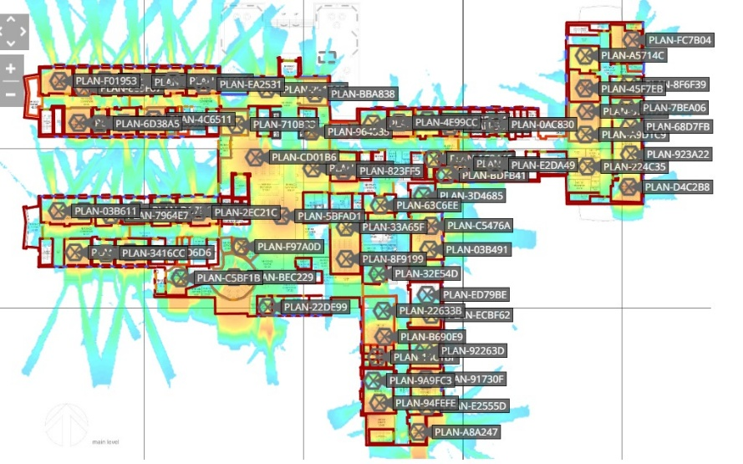

**Figure (Overall Floor Heatmap)**

Our floor was too big to handle, so we divided it into sections. Each group member was assigned one of the following sections: NN, NH, NJ, NR, NL and NK.

**NH Section**

The NH section contains 11 Access Points (APs). This count excludes washrooms and stairwells, which were not considered in the AP placement. Additionally, a bidirectional antenna has been installed to cover the corridors efficiently, ensuring consistent signal coverage along the hallway paths.

**Note on Corridor Coverage:**  
While we planned for a bidirectional antenna to provide coverage in the corridors of the NH section, we encountered a limitation in the Extreme Cloud™ IQ app — the bidirectional antenna option was not available in the antenna selection list. As a result, we had to improvise using available antenna types to approximate the intended coverage. This may slightly affect the accuracy of our corridor signal modeling.

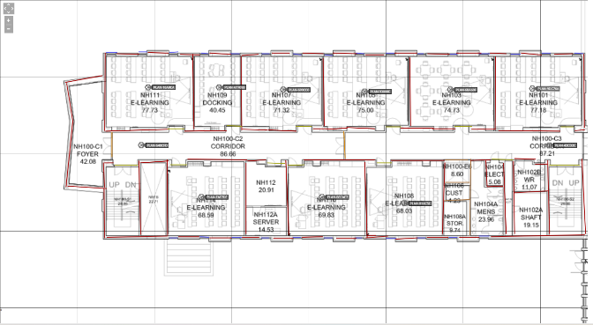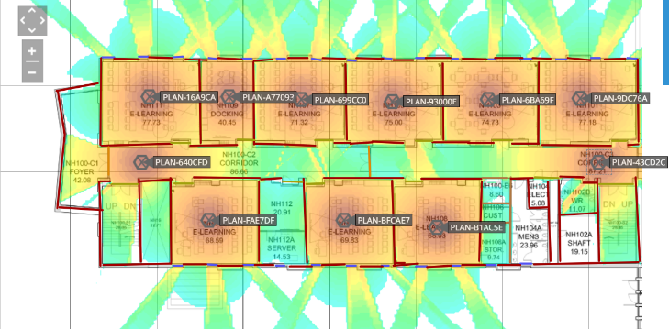

**NJ Section**  
 The NJ section contains 13 Access Points (APs), not including those that would cover washrooms and stairwells. Like the NH section, a bidirectional antenna was planned for corridor coverage.

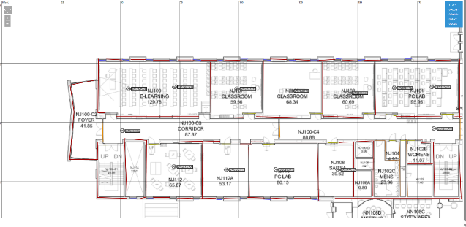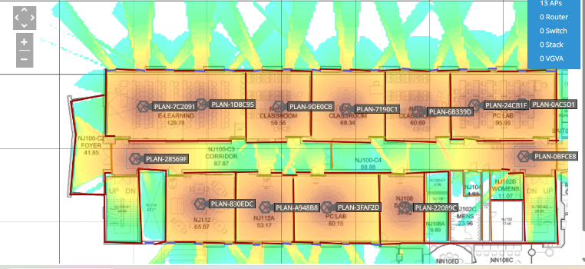

**NK Section**

The NK section had a high concentration of lab rooms, each requiring strong and reliable wireless coverage due to dense user and device presence. To ensure adequate signal strength and performance, a total of 18 Access Points (APs) were deployed across this section. This number excludes coverage for washrooms and staircases, which were not considered in the AP placement. The higher AP count is due to the increased network load and performance requirements in lab environments.

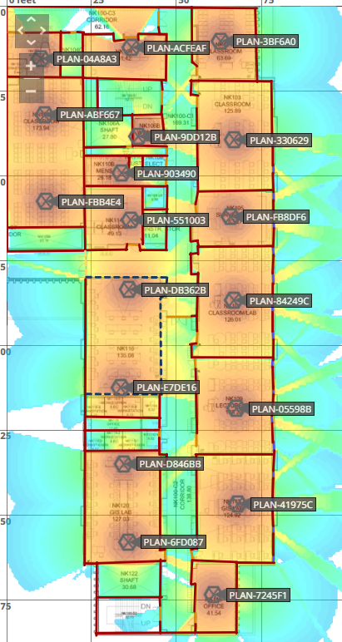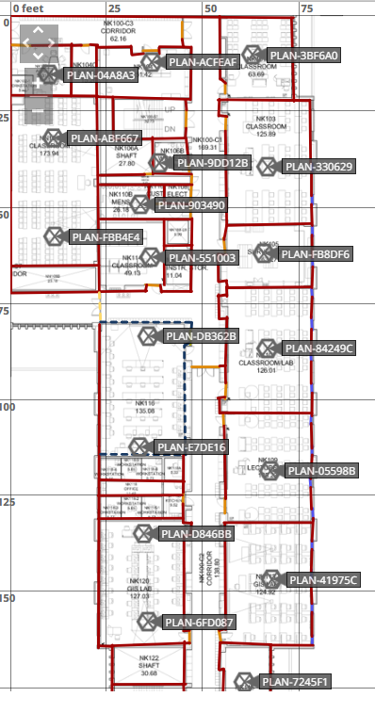

**NL Section**

The NL section primarily consists of closed study rooms and storage rooms. These areas required focused wireless coverage to ensure reliable connectivity in enclosed spaces. A total of 15 Access Points (APs) were deployed to meet these coverage needs. Washrooms and staircases were excluded from the AP planning. The design focused on providing strong signal penetration into closed rooms while minimizing interference between adjacent spaces.

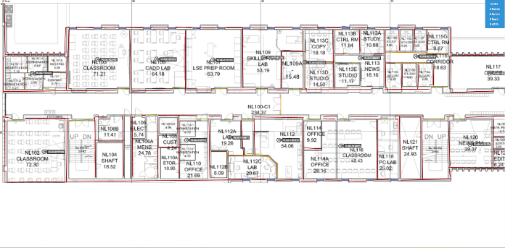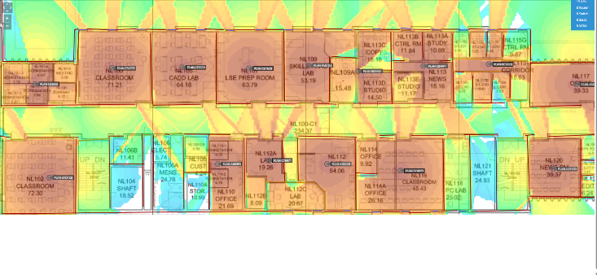

**NN Section**

The NN section was quite large, so it was divided into two parts: top and bottom to facilitate easier wireless planning and AP deployment. Additionally, the theater room, originally intended to be included in the NN section, was moved to the NK section. This change was made because it was difficult to fit the theater room into the NN map. Another important consideration was the elevators and staircase, which were excluded from the AP planning as they do not require wireless coverage. The decision allowed for more efficient coverage planning and ensured the theater room received proper signal support.

**Top Section of NN (8 APs)**

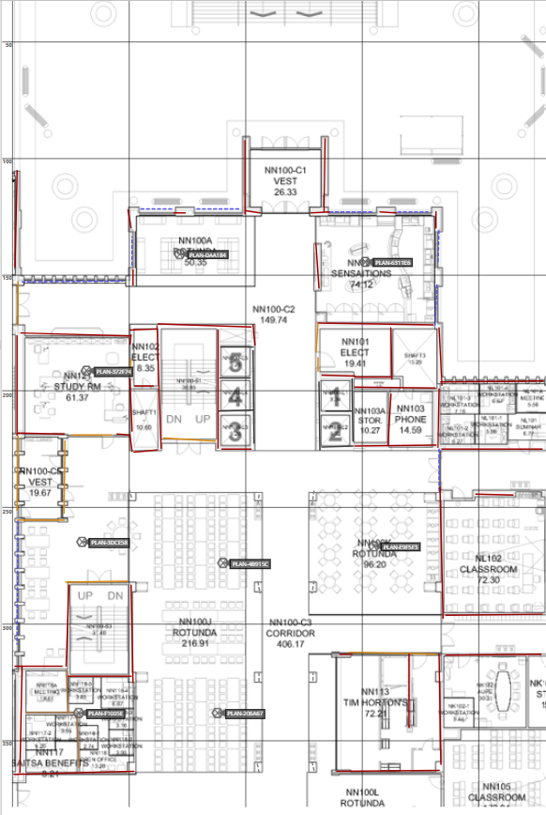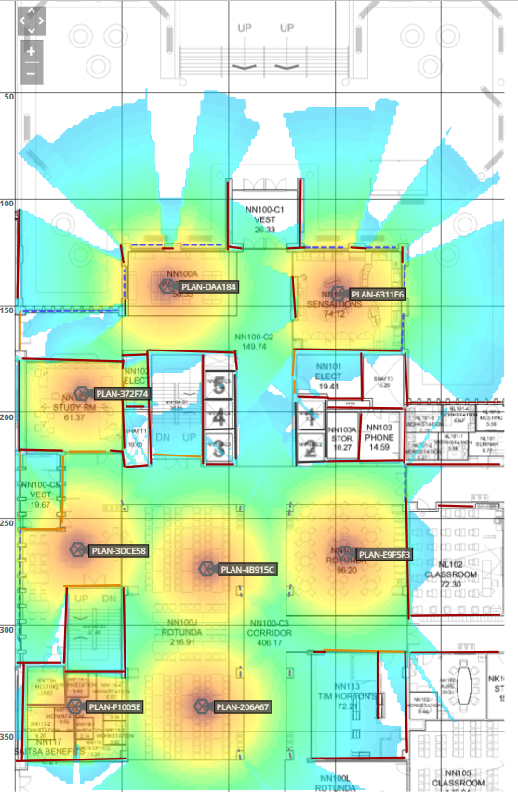

**Bottom Section of NN (6 APs)**

The bottom section primarily includes advising offices and some sitting areas, which required a tailored approach for optimal signal strength

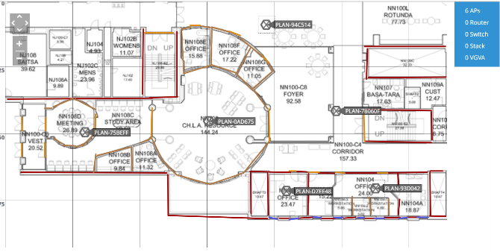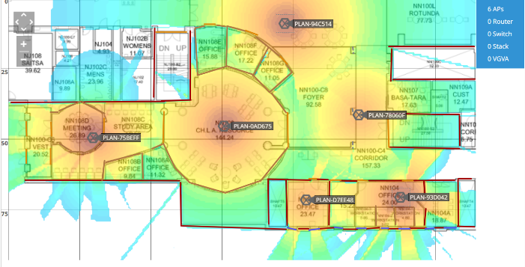

**NR Section (12 APs)**  
The NR section primarily consists of medical classrooms, which require reliable wireless coverage to support student devices and medical equipment. However, medical equipment tends to absorb radio frequencies, which can affect the wireless signal. As a result, AP placement was carefully planned to account for potential interference and to ensure optimal coverage despite the presence of these devices. Additionally, washrooms and staircases were excluded from the AP planning, focusing the coverage on the classrooms where connectivity is critical.

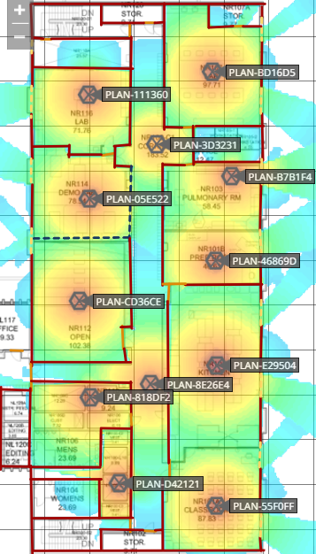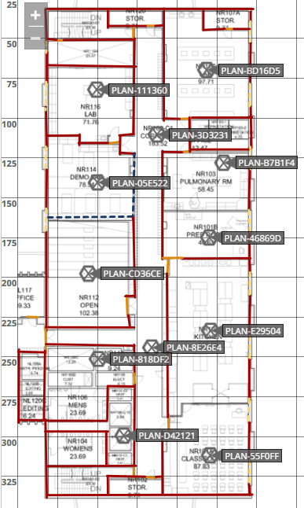

**Implementation Plan**

**Step 1:** Initial Preparation and Site Walkthrough (Day 1)

**Objective:** Prepare for the deployment of Hardware’s and wires.

**Activities:**

* Walk through the site to confirm that the planned access point (AP) locations match the floor plan and make sense in the real-world layout.
* Look out for any potential issues that could impact performance, such as walls, metal surfaces, glass, or areas with heavy foot traffic.
* Check that all plans align with safety requirements and begin mapping out the most efficient and secure paths for cabling.

**Step 2:** Hardware installation and alignment (Day 2)

**Objectives**: Successfully install wireless access points in ideal locations.

**Activities:**

* Mount APs on the ceilings or walls for stable and optimal signal coverage.
* Clearly label each AP according to the assigned location for easy identification.
* Adjust the positioning of the APs as needed to eliminate signal shadows.

**Output:** Properly aligned and securely installed APs according to the design.

**Step 3:** Network Core Configurations (Day 3)

**Objectives:** Configure the switch as the main hub for connectivity.

**Activities:**

* Install the switch in a secure and central location with racks for easy access.
* Configure VLANs to separate traffic and enable Power over Ethernet (PoE) for the APs.
* Verify Ethernet connectivity, check PoE availability and test VLAN configuration.

**Output:** The core of the network is fully setup and provides reliable connectivity and power to the APs.

**Step 4:** Cable Installation (Day 4 and 5)

**Objective:** Install and test ethernet cables to connect all the APs to the central network switch.

**Activities:**

* Clearly label each cable to simplify future troubleshooting and maintenance.
* Perform end to end testing of all the cables to verify reliable connectivity.

**Output:** All the APs are connected to the switch which are fully tested and labeled.

**Step 5:** Wireless LAN Controller configuration (Day 5)

**Objective:** Configuration of the Wireless LAN controller to manage all the APs.

**Activities:**

* Configure all three SSIDs, security settings, and QoS policies to meet performance requirements according to all the areas.
* Enable roaming capabilities so users can move throughout the building without losing connection.
* Separate specific channels and transmission powers to reduce signal interference.

**Output:** The WLC is fully configured and actively managing all the APs.

**Step 6:** Testing and Validation (Day 6 and 7)

**Objective:** Ensuring the wireless network provides consistent coverage and performance across the whole floor.

**Activities:**

* Using site survey tools like tomograph to measure signal strength, identify noise levels, and analyse overall throughput.
* Use personal device and roam around the floor to test roaming and connection stability.
* Detect and resolve any weak spots or any performance issues.

**Output:** A verified wireless network with strong and stable coverage ensuring client mobility across the floor.

**Step 7:** Final Documentation and Review (Day 8)

**Objective:** Complete all the required project documents and present them for review and approval.

**Activities:**

* Gather and organize all the installation records, test results, APs configurations, and heatmaps into a comprehensive report.
* Create a visual map or a topology in Cisco Packet Tracer to illustrate network performance and future reference.
* Submit all the documents to the admins for review and approval.

**Output:** A complete and approved project documentation ready to be handed over to the operations team.

**Bill Of Materials:**

|  |  |  |  |  |  |
| --- | --- | --- | --- | --- | --- |
| **Item No.** | **Quantity** | **Material / Part Number** | **Description** | **Unit Cost** | **Total Cost** |
| 1 | 83 | AP150W | Extreme Networks 802.11ac MU-MIMO, Wave 2 Dual-Radio 2x2:2 Access Point | $400 | **$33,200** |
| 2 | 4 | C9200L-24P4G | 24-port full PoE+ switch with 4x1Gbps uplinks | $1,600 | **$6,400** |
| 3 | 1 | Catalyst 9800-L | Fixed wireless LAN controller for small and midsize enterprises | $15,653 | **$8,139.99** |
| 4 | 8,300m | Cat 6 Cabling | Ethernet cabling (100m per AP) | $0.744/m | **$6,175.20** |
| Total Cost |  |  |  |  | $53,915.19 |

**Coverage and Performance Validation**

For a reliable wireless performance, we conducted a detailed site survey using Tamo Graph. Because of the large area of the floor, the survey was performed in section to maintain precision. During our survey we were not able to access all the rooms due to being locked. To solve this problem, we adjusted the guess range settings within Tamo Graph, which enabled the software to estimate signal coverage in those rooms based on surrounding measurements. This allowed us to account for coverage in locked rooms without compromising data accuracy. The survey results indicated strong signal strength and consistent coverage across the whole floor. We took some screen captures from our survey.

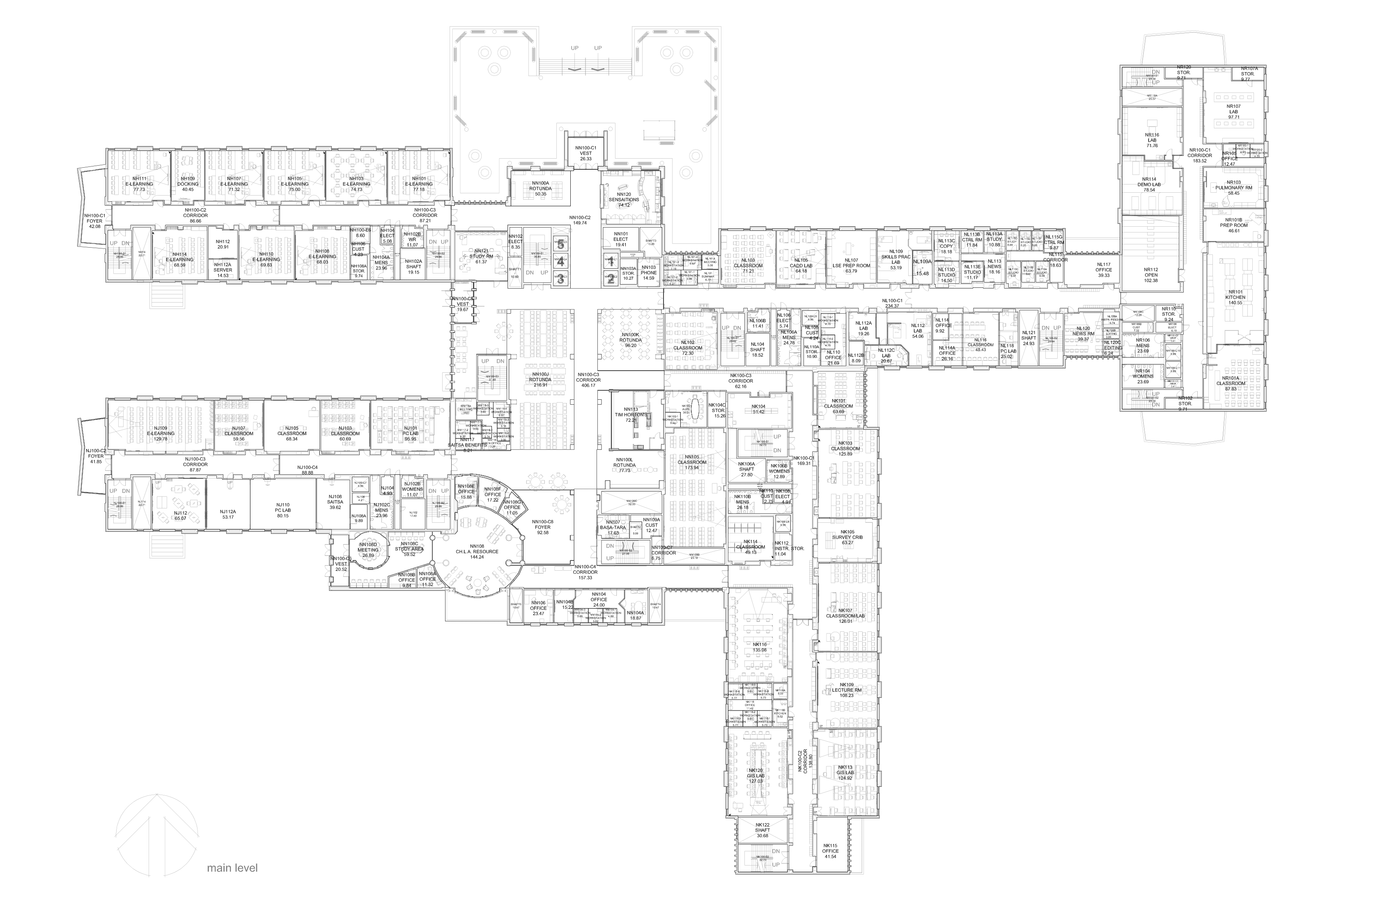

**Figure 7 (Overall Floor)**

**NJ and NN Section**

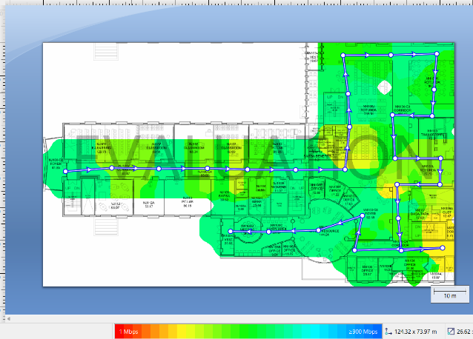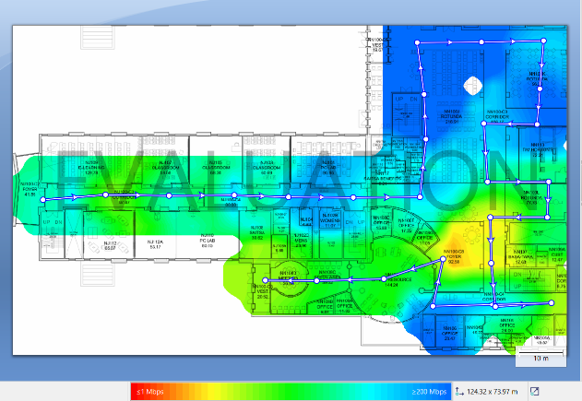

Actual Physical Rate TCP Downstream

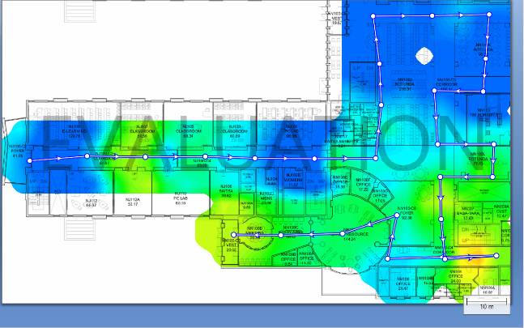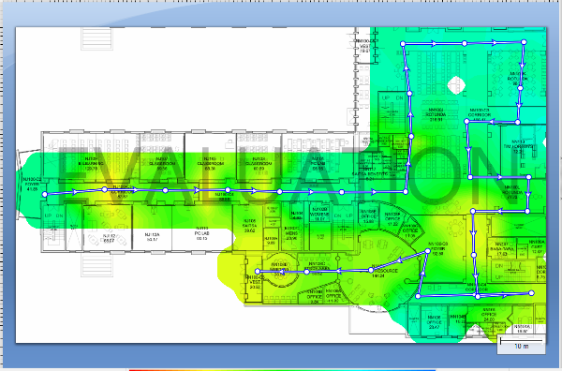

TCP Upstream UDP Downstream

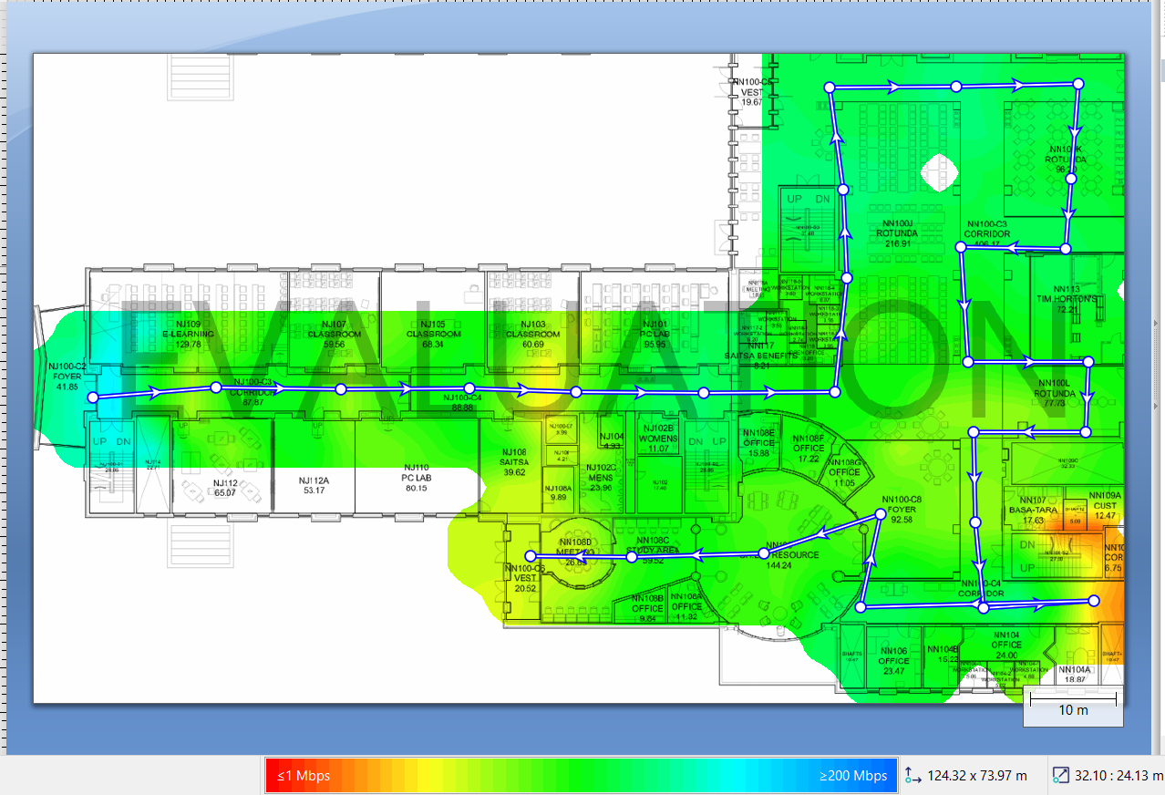

UDP Upstream

**NK Section**

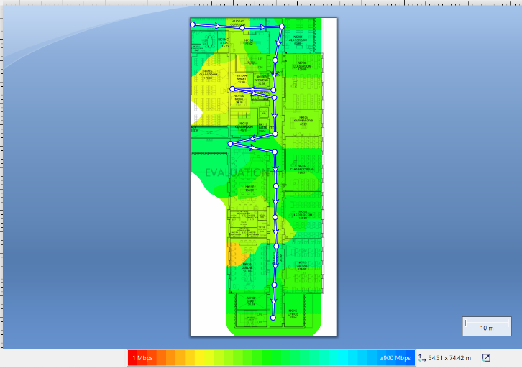

Actual Physical Rate

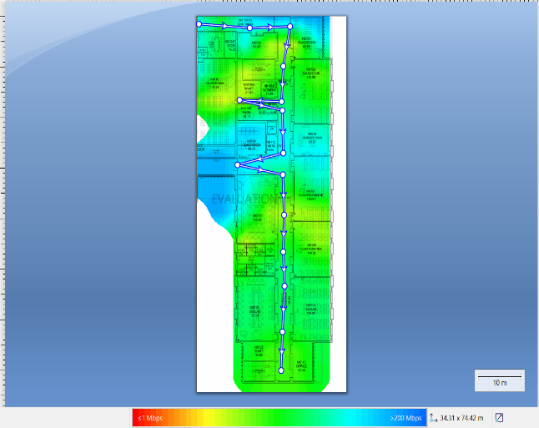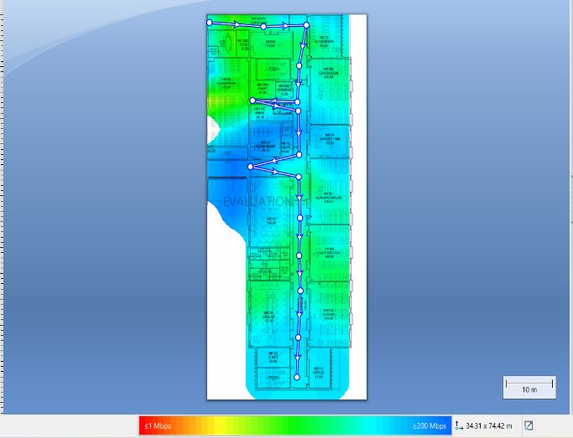TCP Downstream TCP Upstream

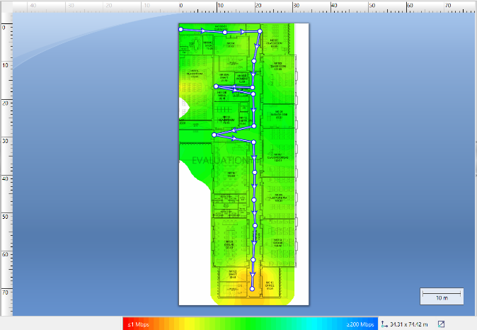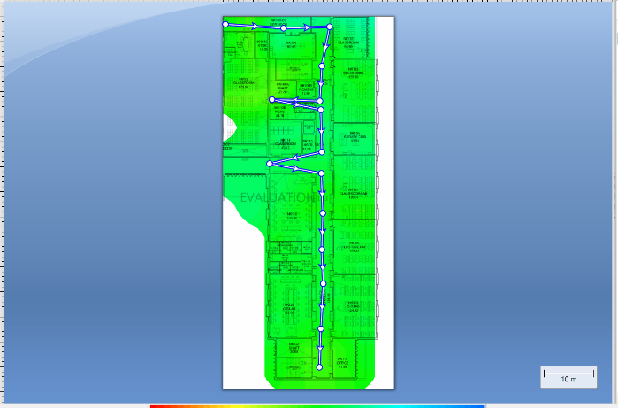

UDP Downstream UDP Upstream

**NL NL NH Section**

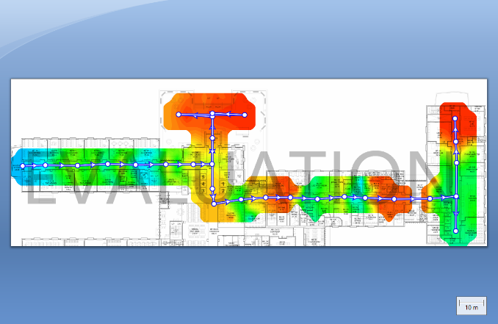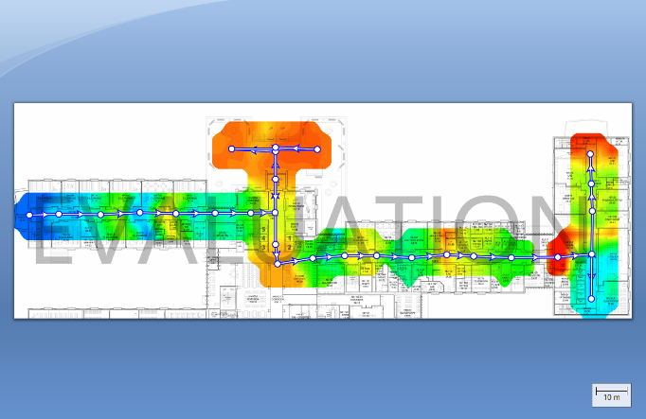

TCP Downstream TCP Upstream

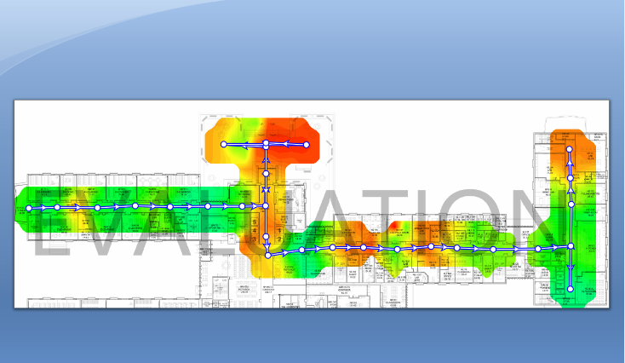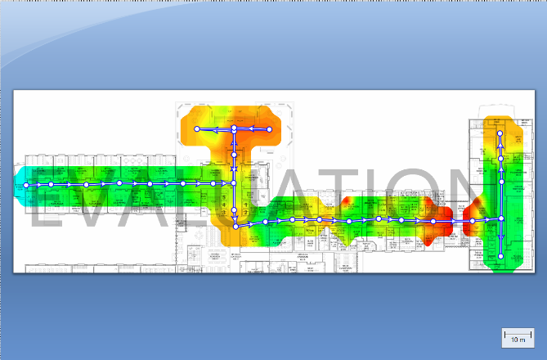

UDP Downstream UDP Upstream

**Recommendations for Post-Implementation Improvement**

* **Channel Optimization:**

Select optimized channel to reduce co-channel and adjacent interference from overlapping coverage.

* **AP Adjustment:**

Reposition the APs closer to the high-traffic or weak signal zones within Senator Burns Building. This ensures better signal strength and a more balanced user experience.

* **Adjust Power Level Calibration:**

Adjust transmit power settings in overlapping areas to reduce signal overlap, minimize interference, and improve overall airtime efficiency.

These ongoing adjustments will help maintain consistent WLAN performance, enhances user experience, and remains adaptive to usage patterns.